**Template Week 6 – Networking**

Student number: 546746

**Assignment 6.1: Working from home**

Screenshot installation openssh-server:

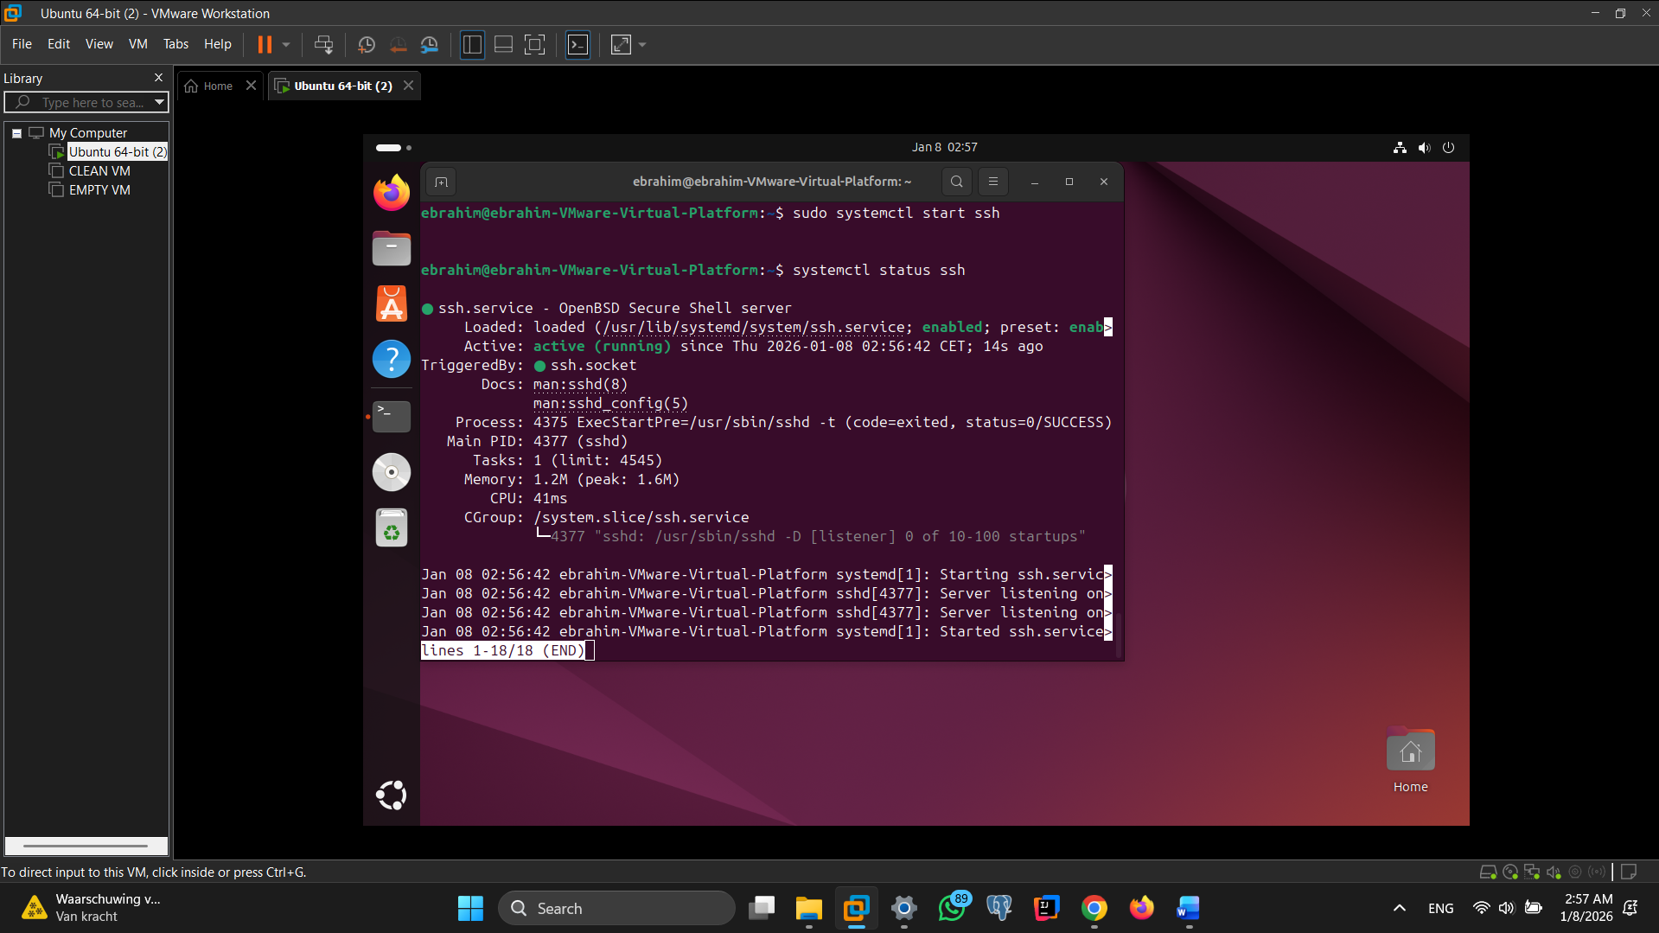

Screenshot successful SSH command execution:

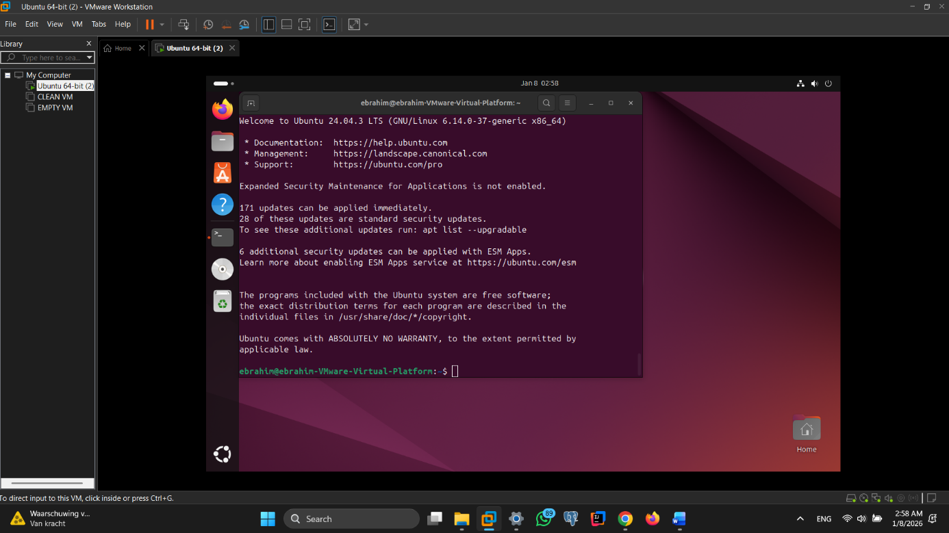

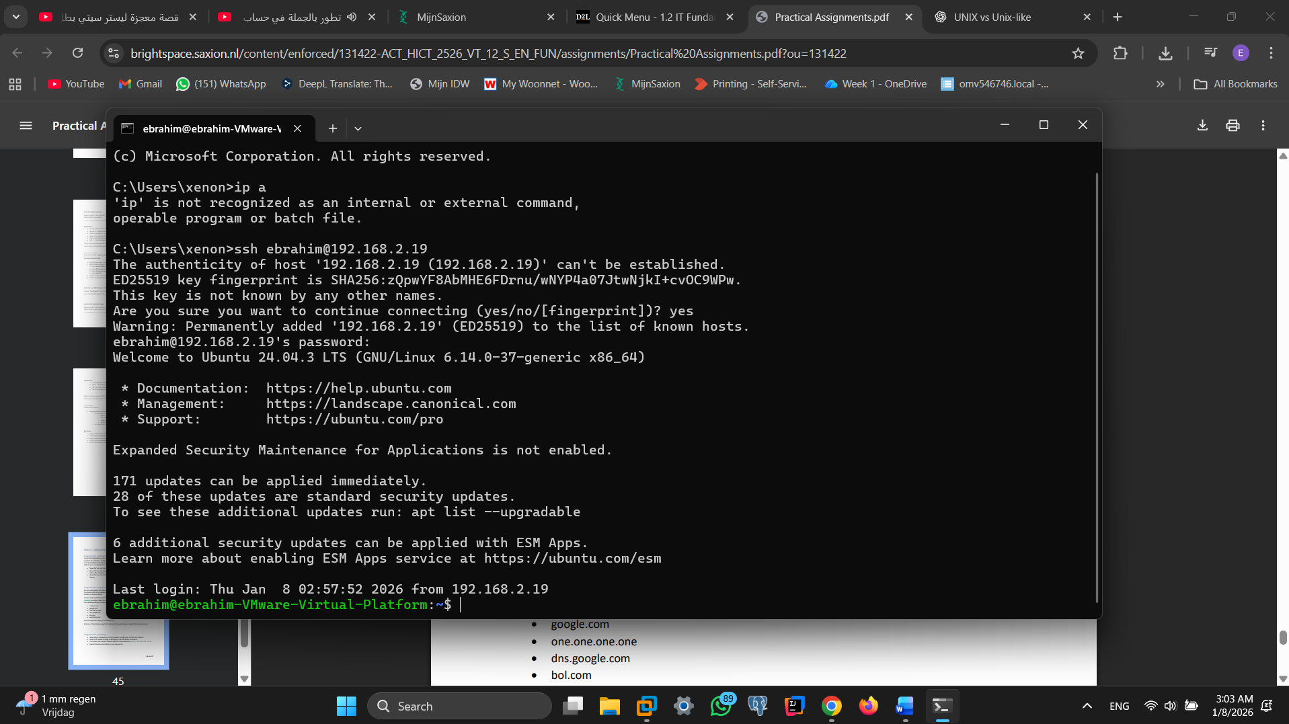

Screenshot successful execution SCP command:

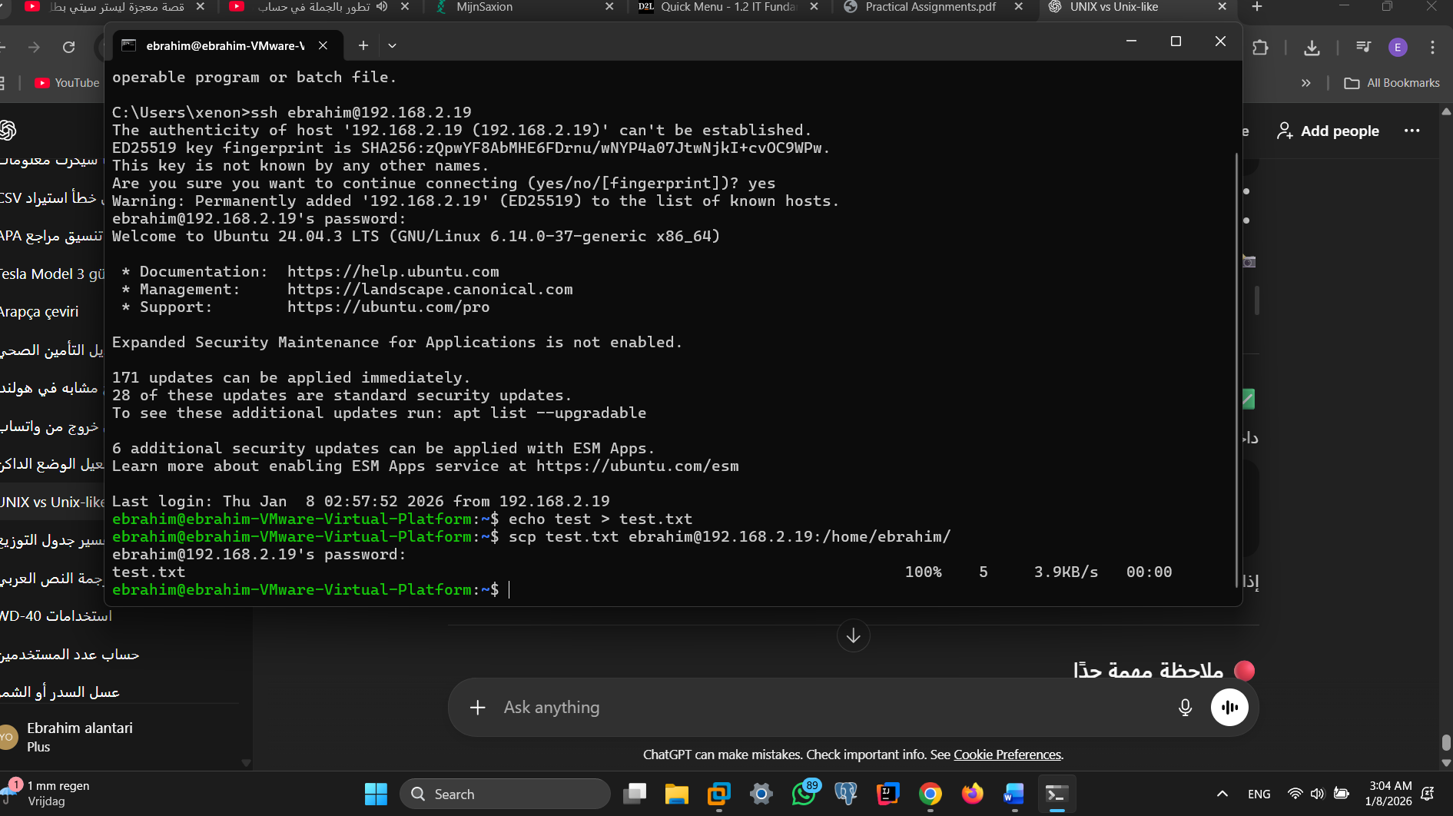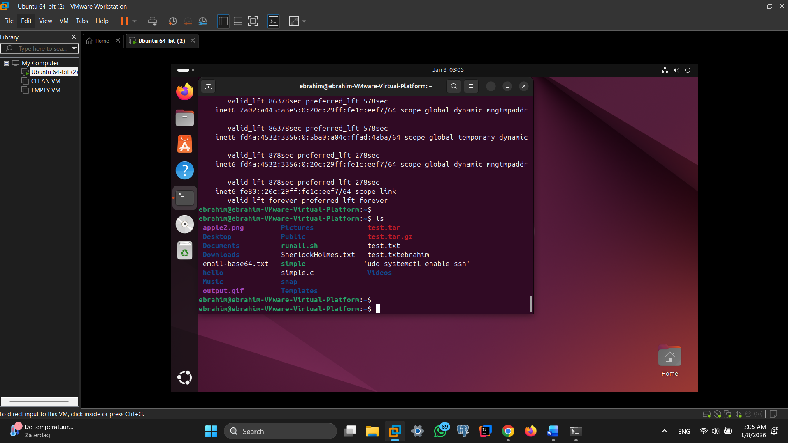

Screenshot remmina:

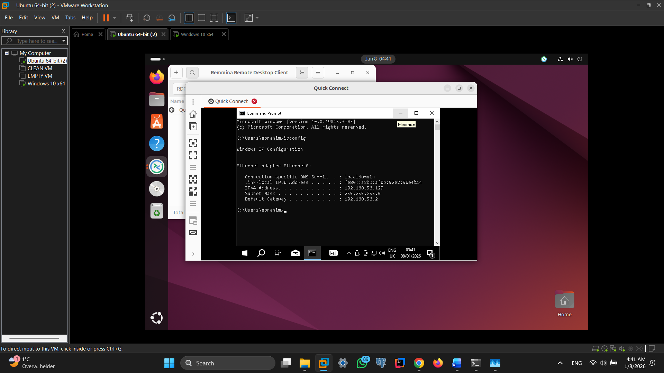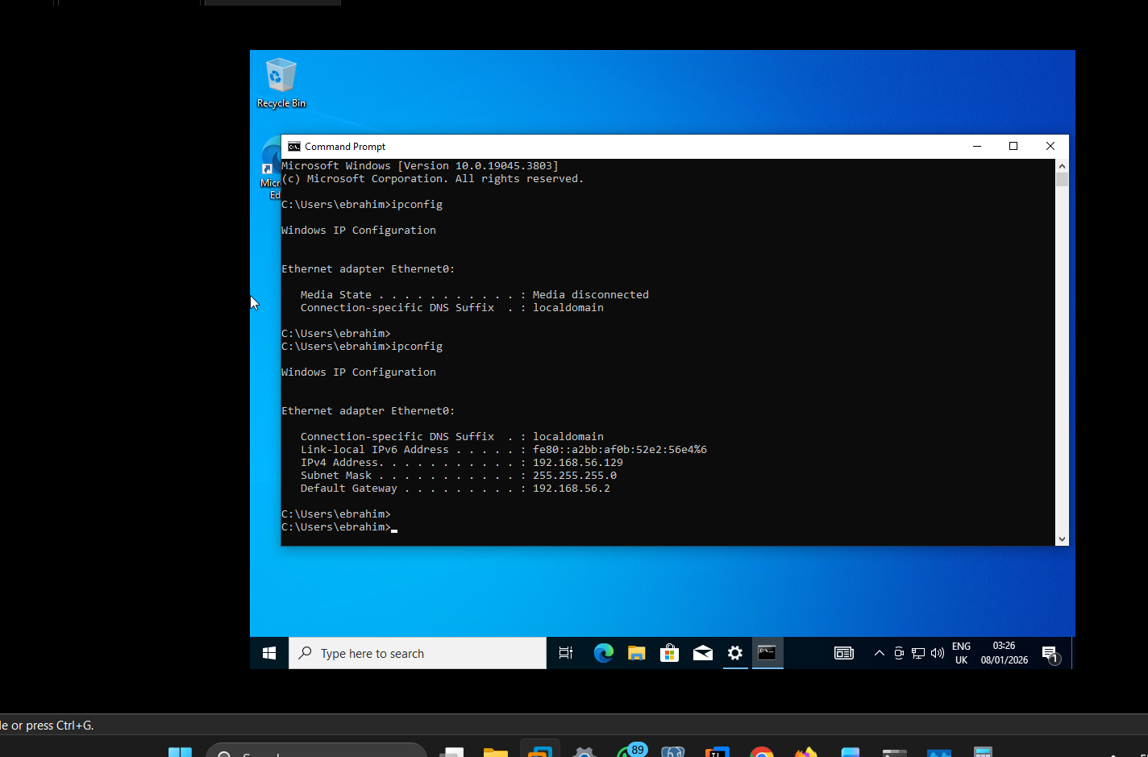

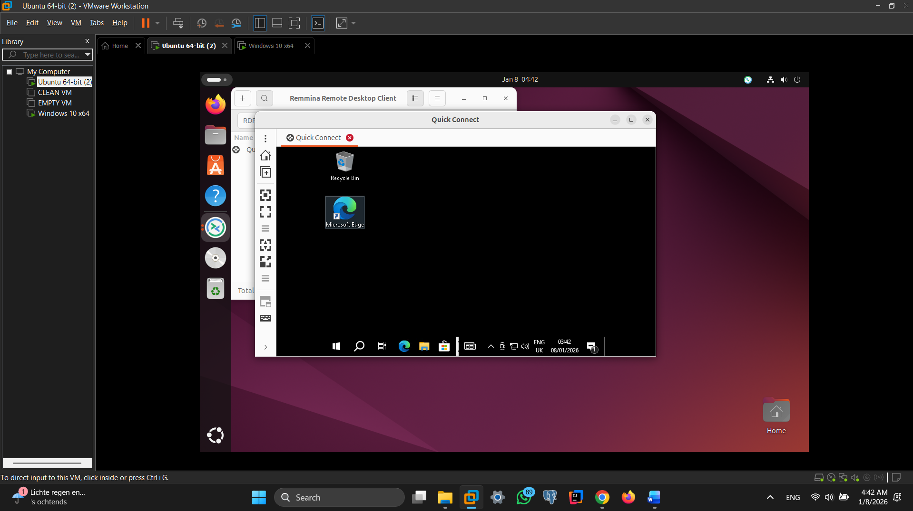

**Assignment 6.2: IP addresses websites**

Relevant screenshots nslookup command:

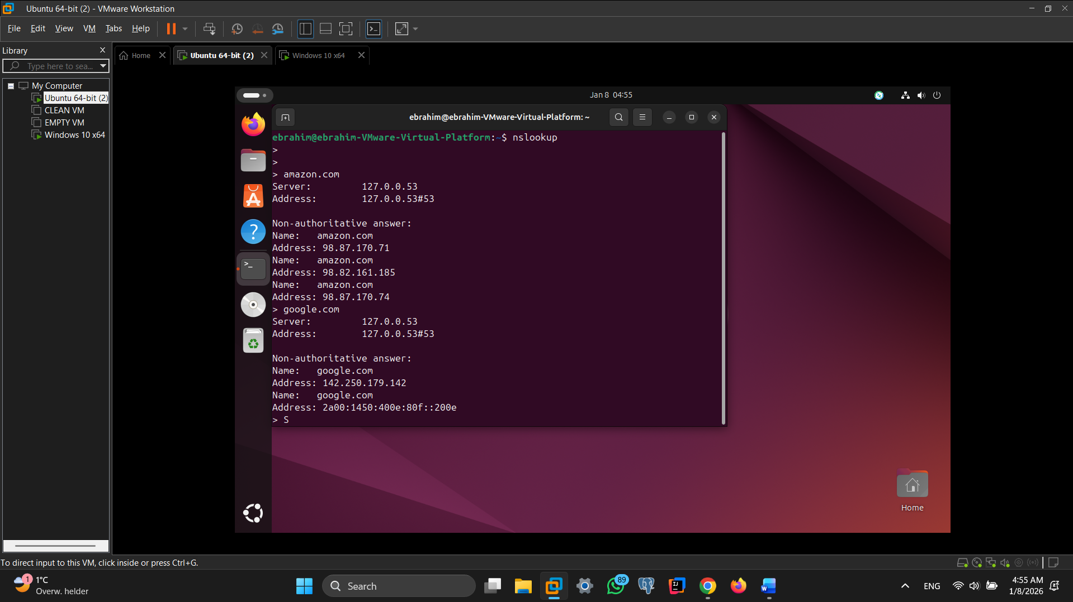 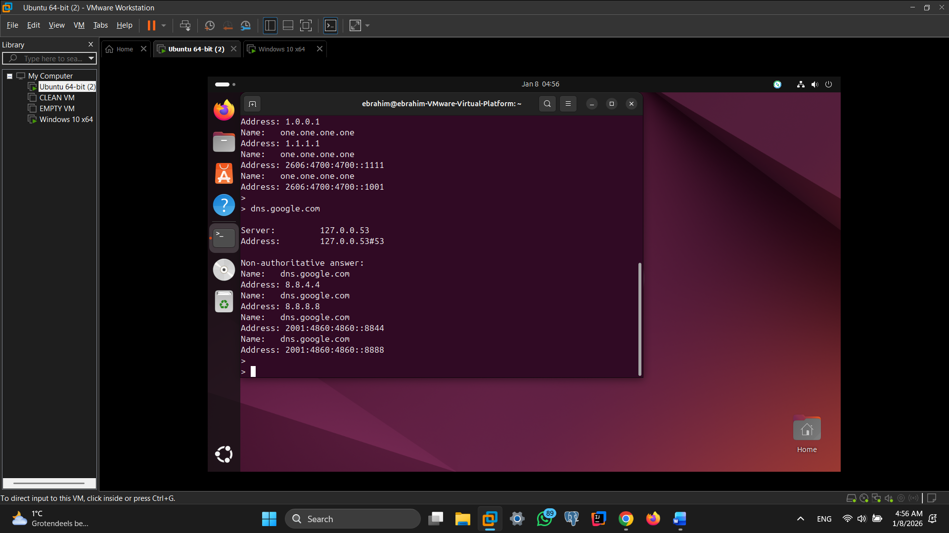 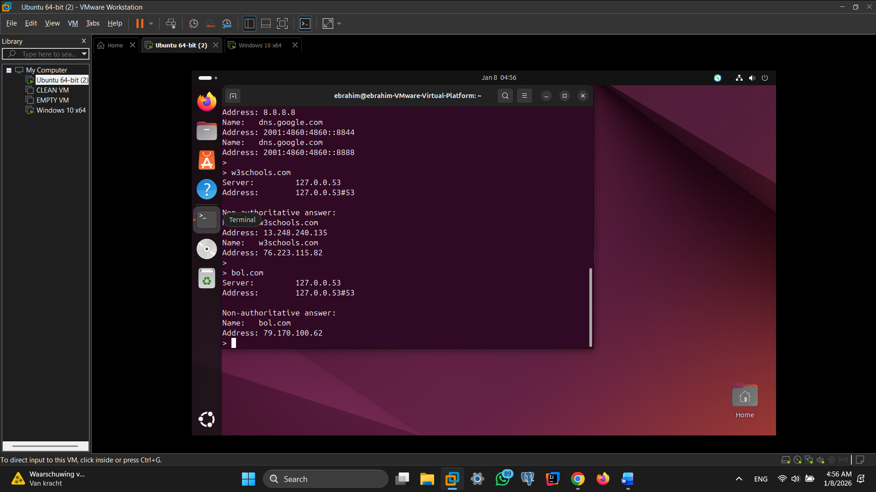

Screenshot website visit via IP address:

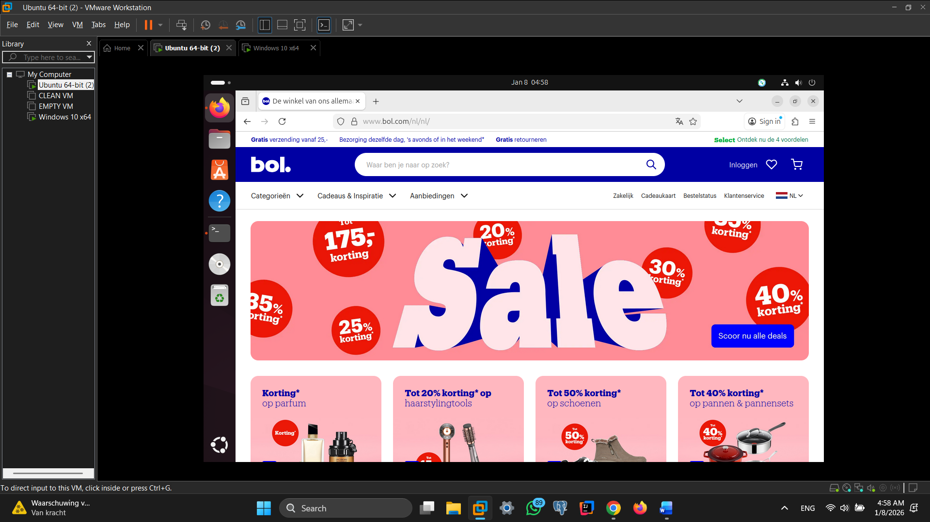

**Assignment 6.3: subnetting**

How many IP addresses are in this network configuration 192.168.110.128/25?

The network 192.168.110.128/25 uses 25 bits for the network and 7 bits for hosts.  
This results in 2⁷ = 128 total IP addresses.  
The first address is the network address and the last address is the broadcast address, so they cannot be assigned to hosts

What is the usable IP range to hand out to the connected computers?

the usable IP range is from 192.168.110.129 to 192.168.110.254, providing 126 usable host addresses.

Check your two previous answers with this Linux command: ipcalc 192.168.110.128/25

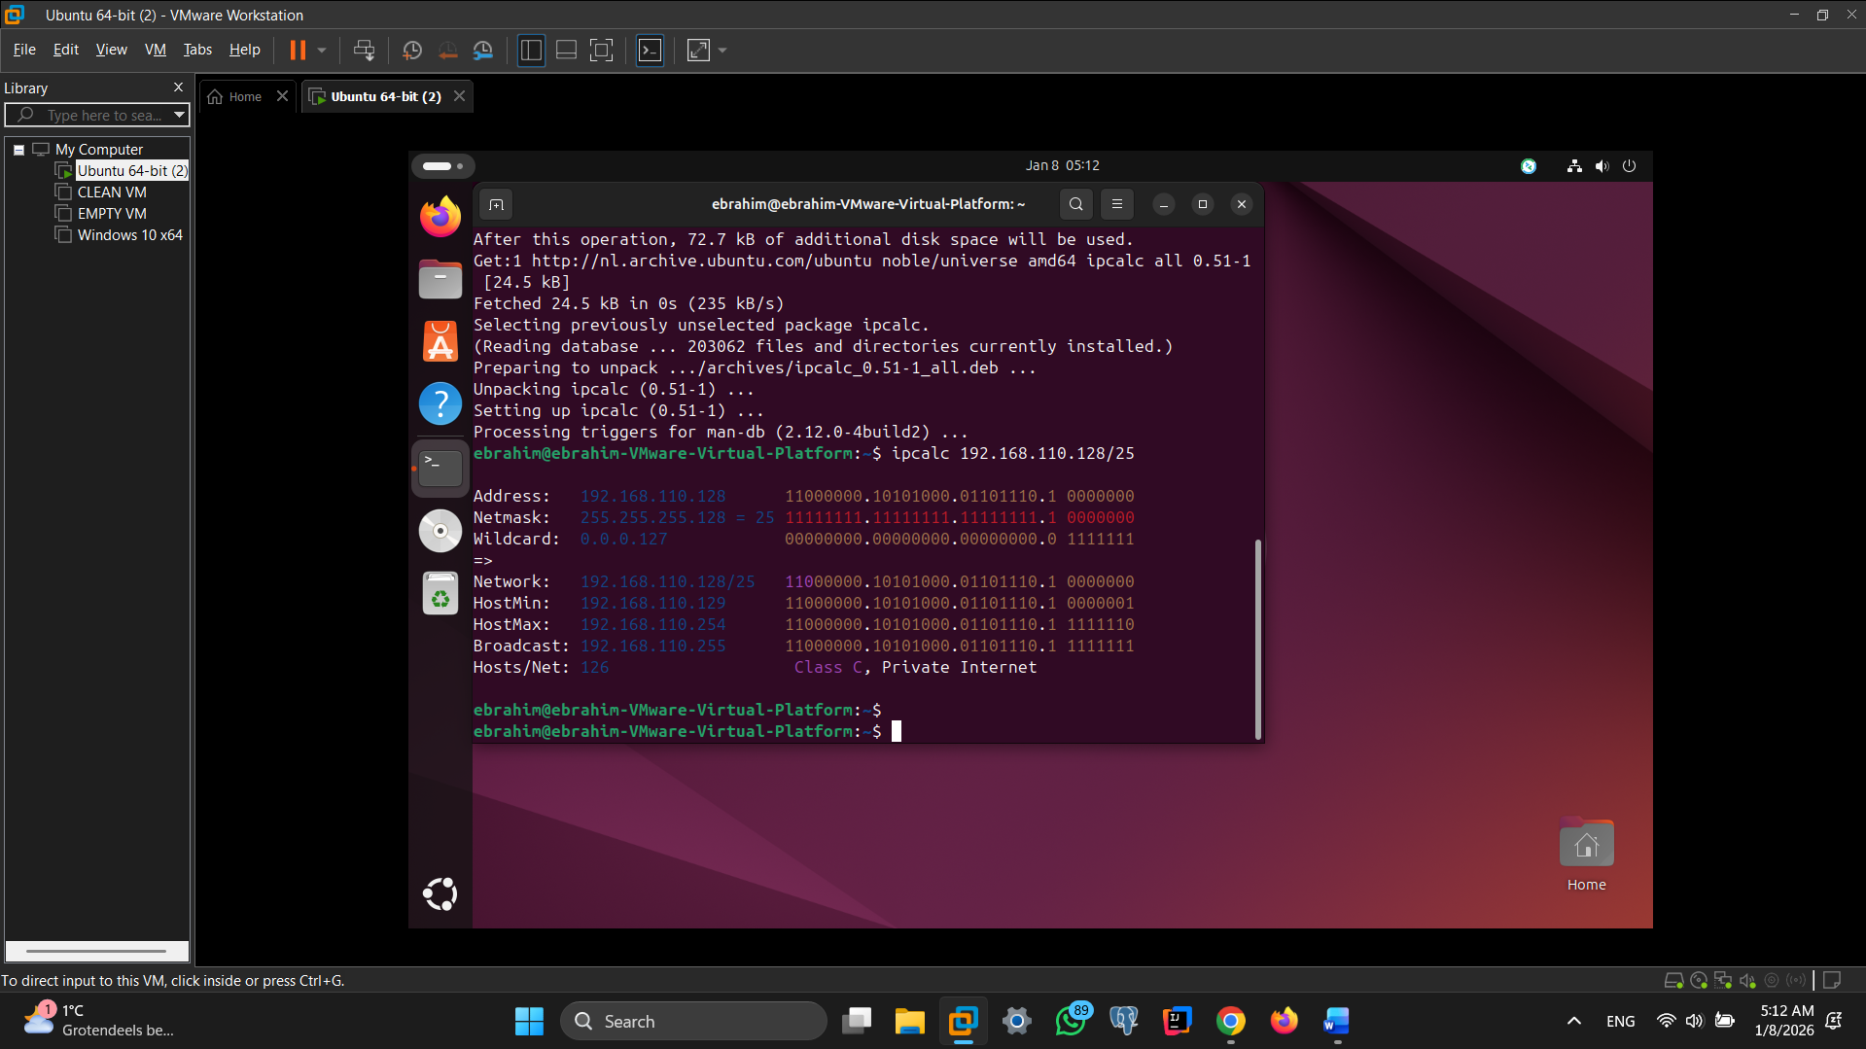

Explain the above calculation in your own words.

The first address is the **network address** and the last address is the **broadcast address**, so they cannot be used by devices.  
This leaves **126 usable IP addresses**, ranging from **192.168.110.129 to 192.168.110.254**.  
The result was confirmed using the **ipcalc** command.

**Assignment 6.4: HTML**

Screenshot IP address Ubuntu VM:

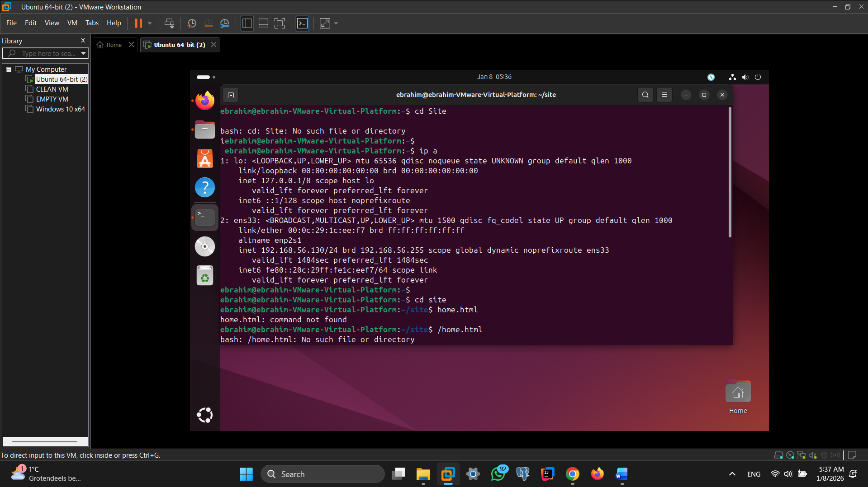

Screenshot of Site directory contents:

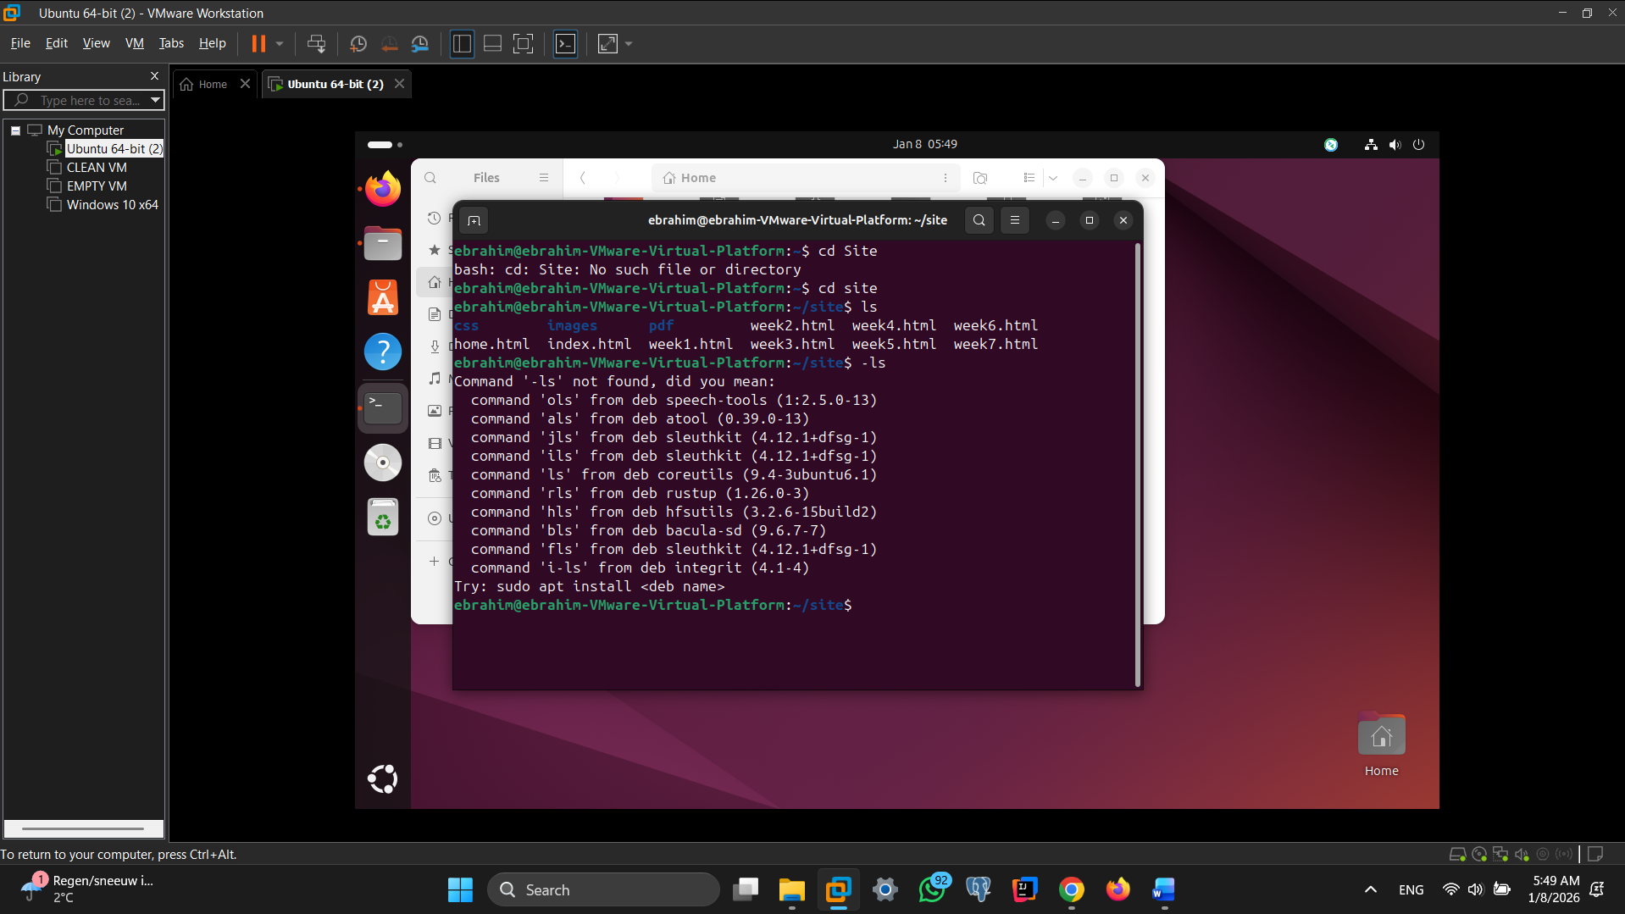

Screenshot python3 webserver command:

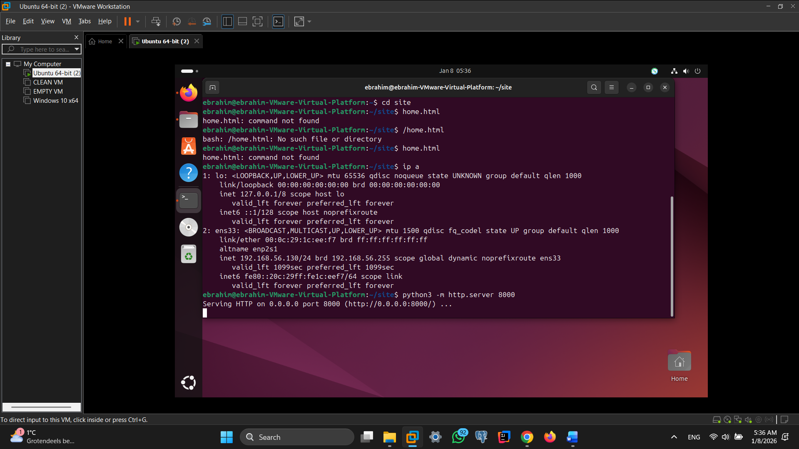

Screenshot web browser visits your site

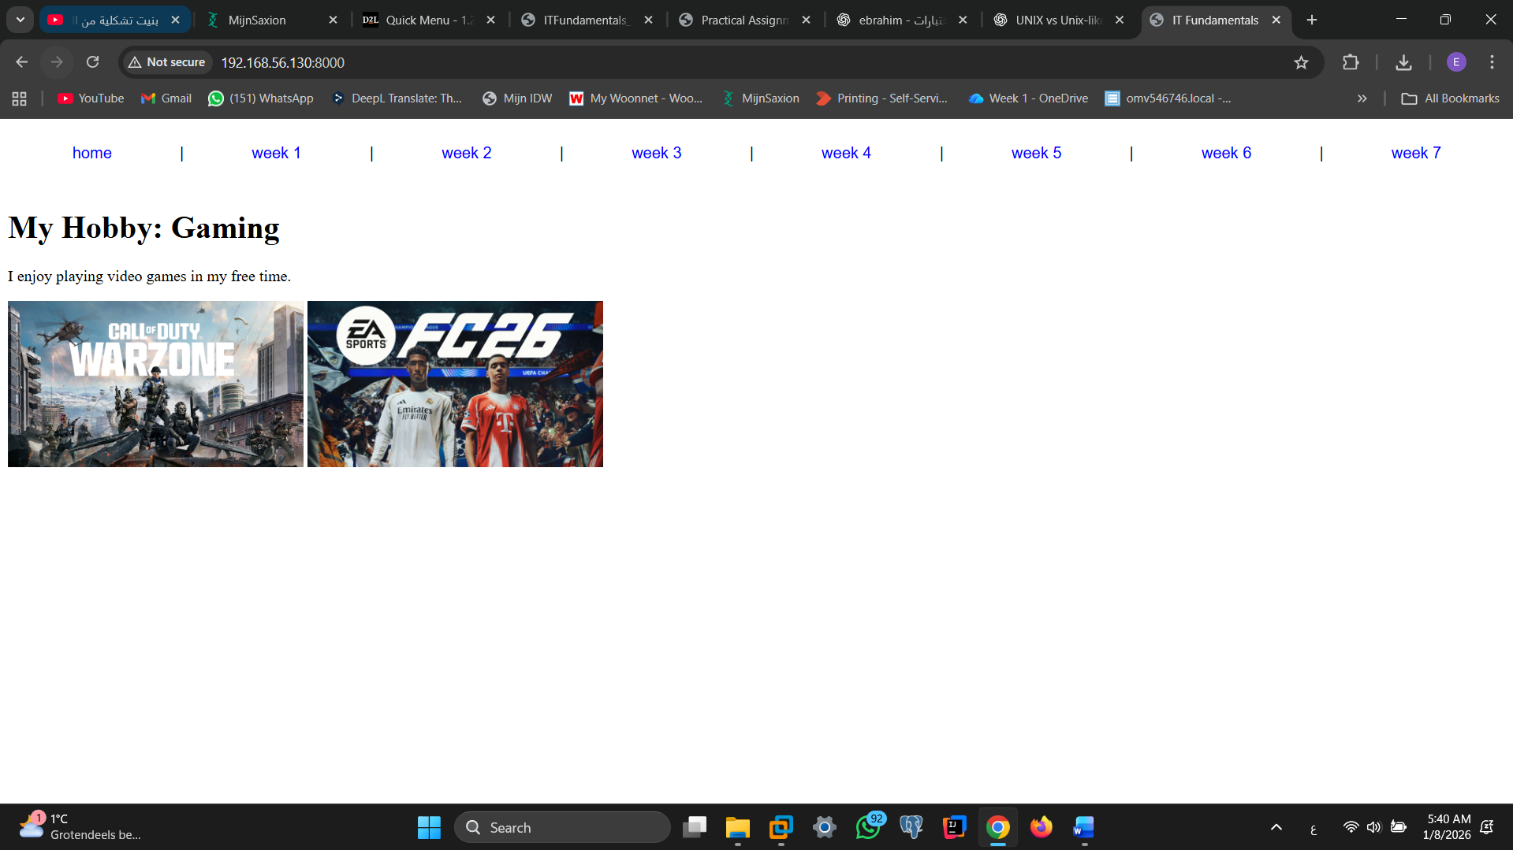

**Assignment 6.5: Network segment**

Remember that bitwise java application you’ve made in week 2? Expand that application so that you can also calculate a network segment as explained in the PowerPoint slides of week 6. Use the bitwise & AND operator. You need to be able to input two Strings. An IP address and a subnet.

IP: 192.168.1.100 and subnet: 255.255.255.224 for /27

Example: 192.168.1.100/27

Calculate the network segment

IP Address: 11000000.10101000.00000001.01100100

Subnet Mask: 11111111.11111111.11111111.11100000

-------------------------------------------------

Network Addr: 11000000.10101000.00000001.01100000

This gives 192.168.1.96 in decimal as the network address.

For a /27 subnet, each segment (or subnet) has 32 IP addresses (25). The range of this network segment is from 192.168.1.96 to 192.168.1.127.

Paste source code here, with a screenshot of a working application.

public class NetworkSegment {

public static void main(String[] args) {

String ip = "192.168.1.100";

String subnet = "255.255.255.224";

String[] ipParts = ip.split("\\.");

String[] subnetParts = subnet.split("\\.");

System.out.println("Network Address:");

for (int i = 0; i < 4; i++) {

int ipOctet = Integer.parseInt(ipParts[i]);

int subnetOctet = Integer.parseInt(subnetParts[i]);

int networkOctet = ipOctet & subnetOctet;

System.out.print(networkOctet);

if (i < 3) System.out.print(".");

}

}

}

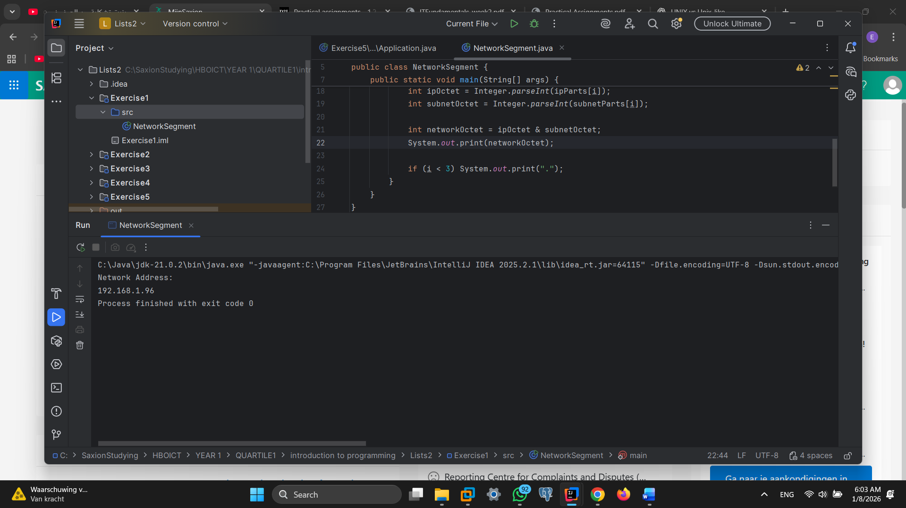

Ready? Save this file and export it as a pdf file with the name: **week6.pdf**